**Outline**

Play the original Simon game to establish a mind-set around basic game systems. Research the history of game systems. Analyze the Simon game from an input-process-output perspective.

**Objectives**

* Use the input-process-output model to solve programming problems.
* Use industry-standard programming tools (e.g., UML [Unified Modeling Language], diagrams, structure charts, flow charts, pseudocode) to develop a software project.

**Prerequisites**

|  |  |  |  |  |
| --- | --- | --- | --- | --- |
| **Prerequisite Module(s)** | **Level** | **Student Initial** | **Teacher Initial** | **Date** |
| None |  |  |  |  |

**Materials**

* Simon game obtained from teacher

**Level 0: Play the Simon Game**

Play the Simon game in your group while taking note of the following game-play items:

1. What was your personal best score?

7 was my personal best.

1. What was the personal best score in your group?

11 was the personal best score in my group.

1. What makes it a good game?

The game was challenging.

1. In what ways is it similar to modern computer games?

In Simon you have to remember the patterns which you have to do in most games.

Play the Simon game in your group while taking note of the following technical items:

1. How do users input information into the game?

The users push buttons.

1. How does the game output feedback to the players?

The game will make a sound to let the user know if you did the pattern wrong.

1. What are the game options for starting the game?

Solo and group.

1. What are the end conditions for stopping the game?

It ends the game and tells you the score.

**Level 1: Simon History**

Suggested web resource: http://americanhistory.si.edu/collections/search/object/nmah_1302005

Research the history of the Simon game, focusing on the following questions:

1. Who created Simon?

Ralph Baer created the game.

1. What previous game was it based on?

Atari’s game

1. What was the first game system?

Magnavox odyssey

1. What games did it have on it?

Analogic, Submarine, and Table Tennis

In your group, discuss the following questions:

1. What is the oldest game system you have played on?

PlayStation 1

1. How are old games different from current games?

Graphics, gameplay, controls, and more things to do

1. How are old games similar to current games?

Controls

**Level 2: Input – Output Analysis**

1. List all of the user input objects and actions using a table similar to the one below.

|  |  |  |
| --- | --- | --- |
| **Object** | **Action** | **Description** |
| e.g. Red Button | e.g. Push | e.g. Starts the game |
| e.g. Red Button | e.g. Push | e.g. Record a step in the pattern |
| e.g. Green Button | e.g. Push | e.g. Starts group mode |
| e.g. Yellow Button | e.g. Push | e.g. Record a step in the pattern |
| e.g. Green Button | e.g. Push | e.g. Record a step in the pattern |
| e.g. Blue Button | e.g. Push | e.g. Record a step in the pattern |

1. List all of the user output objects and actions using a table similar to the one below.

|  |  |  |
| --- | --- | --- |
| **Object** | **Action** | **Description** |
| e.g. Red Light | e.g. Flash | e.g. Indicates a step in the pattern |
| e.g. Red Sound | e.g. Play tone | e.g. Indicates a step in the pattern |
| e.g. Blue Light | e.g. Flash | e.g. Indicates a step in the pattern |
| e.g. Blue Sound | e.g. Play tone | e.g. Indicates a step in the pattern |
| e.g. Yellow Light | e.g. Flash | e.g. Indicates a step in the pattern |
| e.g. Yellow Sound | e.g. Play tone | e.g. Indicates a step in the pattern |
| e.g. Green Light | e.g. Flash | e.g. Indicates a step in the pattern |
| e.g. Green Sound | e.g. Play tone | e.g. Indicates a step in the pattern |

1. List all of the all of the ways that an input action results in an output action using a table similar to the one below.

|  |  |  |
| --- | --- | --- |
| **Input Object** | **Output Object** | **Process Connection** |
| e.g. Red Button | e.g. Red Light | e.g. Flashes when button is pushed |
| e.g. Yellow Button | e.g. Yellow Light | e.g. Flashes when button is pushed |
| e.g. Blue Button | e.g. Blue Light | e.g. Flashes when button is pushed |
| e.g. Green Button | e.g. Green Light | e.g. Flashes when button is pushed |

**Level 3: Flowchart Conventions**

Suggested web resource: <https://www.smartdraw.com/flowchart/>

1. Draw and explain the basic flow chart symbols.

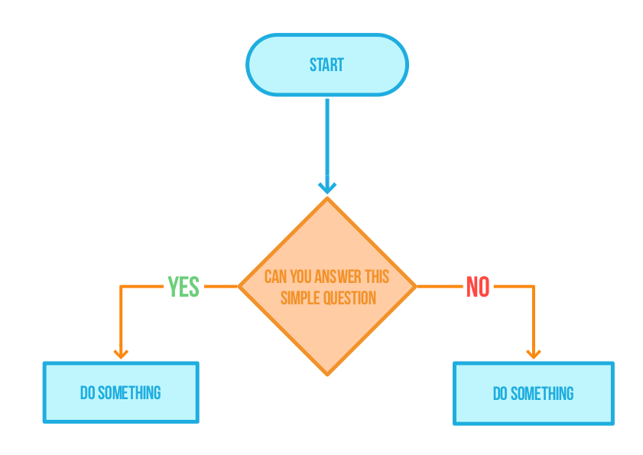

1. Create an example flow chart that uses each basic symbol at least twice.

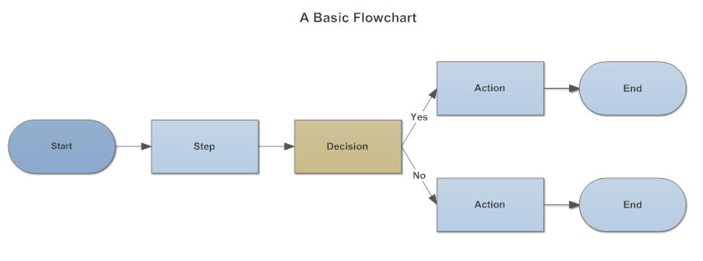

**Level 4: Flowchart the Simon Game**

1. Create a flow chart showing the process connections for a three-tone pattern in the middle of the Simon game.
2. EXTENSION: Create a flow chart for the whole Simon game.

Flowchart for both questions

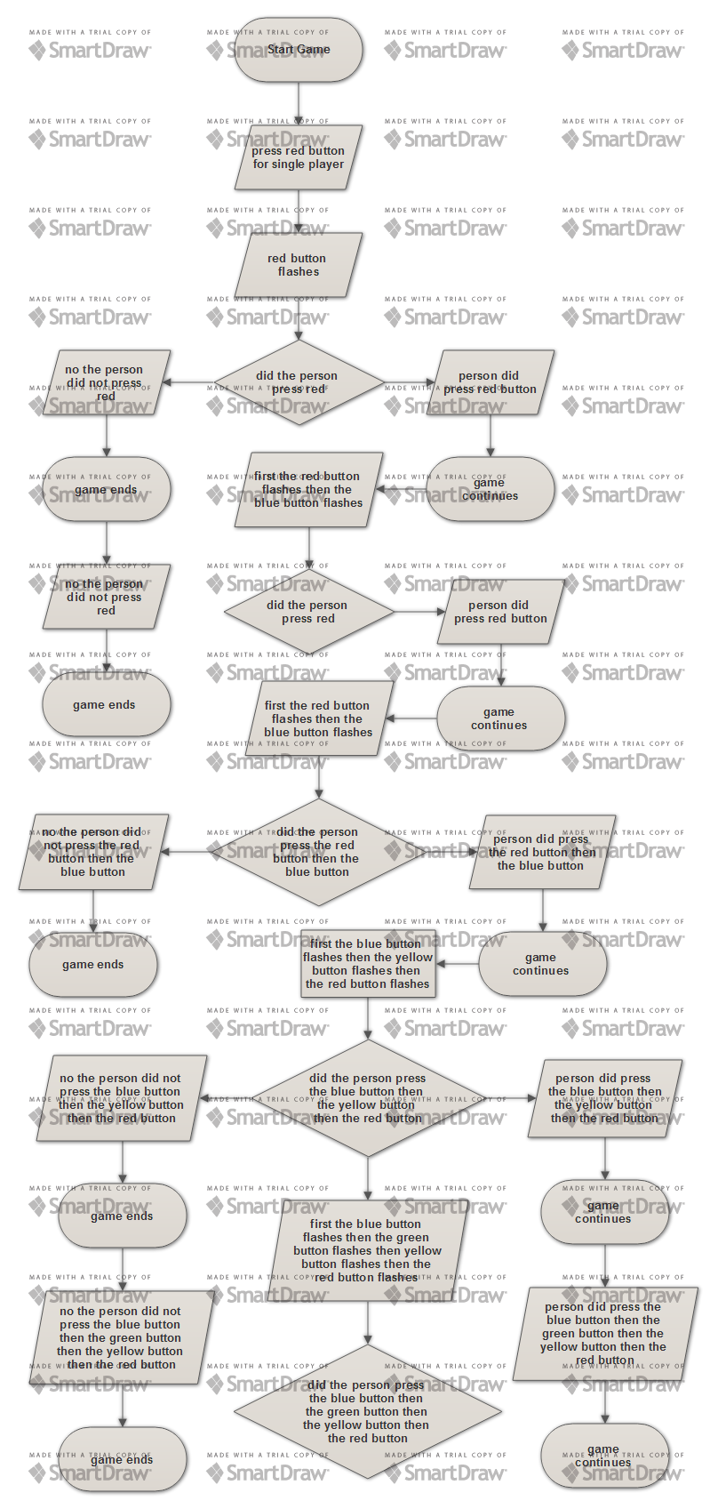

**Achievement Record – Module A.1: Simon Game Icebreaker**

|  |  |  |  |
| --- | --- | --- | --- |
| **Attainment Level** | **Student Initial** | **Teacher Initial** | **Date** |
| Level 0: Play the Simon Game |  |  |  |
| Level 1: Simon History |  |  |  |
| Level 2: Input – Output Analysis |  |  |  |
| Level 3: Flowchart Conventions |  |  |  |
| Level 4: Flowchart the Simon Game |  |  |  |